**Home page:**

The 25th of January 2011, is the date when the Egyptian revolution was born, a part from the Arab spring, flowers bloomed in Egypt's streets. The Egyptian revolution is not just a revolution it's a symbol of resistance, a vibe that everyone still feel when we walk downtown Cairo, you see it on the walls, on the faces of people and hear it in the unspoken words.

The evil powers always fight revolutions. However, revolutions are ideas, and ideas never die. By this festival we make revolutionary ideas live forever, and we honour the memory of the great revolution of the 25th of January.

The festival was supposed to start in 2021 but it was difficult because of the Covid lock down, now the image is clearer and we decided to rebirth the festival as we see it as a platform for all the revolutionary ideas.

**About**

This is how the idea of founding this film festival came to us. We are trying to spread the idea of the revolution, in any place on earth. It doesn’t matter where you come from. As the Egyptian revolution inspired the whole world we hope that our festival will inspire film makers all over the world.

However we want to explain something very important, our festival is supporting revolutionary ideas not necessarily led to political revolution, it can be ideas that might lead to musical ideas, social movements, refugees support ideological revolutions or ideas than can change the view of a certain image or inspiring ideas to change societies or help them to make their lives better. We are standing for the word revolution with the overall meaning of the word.

**25 January film festival team**

1. Chairman: Salah Amer:

Egyptian from Suez city living in the Netherlands, he holds a BA in commerce and he made advanced studies in political science. He is also an a activist, with a big experience in organizing conferences and public events, he also assisted in organizing Amalyashi festival in 2022.

1. CO: Tommy Sherif:

Egyptian artist from Mansoura city in Egypt and he lives in the Netherlands, he studied cinema and theatre in Egypt and the Netherlands, he also holds a BA in law. He is a political and humanitarian activist from 2007. Tommy organized several events and festivals in Egypt and the Netherlands. He is the director of 999 Geen Dienst studio and the director of Amalyashi theatre festival.

1. Media spokesperson: Adham Hasanin:

Adham is from Cairo – Egypt and he lives in the Netherlands, he holds a BA in media and mass communication from Cairo University. He worked as a journalist and a script writer and a fixer in several TV channels, newspapers and platforms such us AlShark TV and Taked platform.

1. Marketing and social media manager: Obada elSharbatly:

Egyptian from Alexandria and he lives in the Netherlands. Finish it yourself and write what you want.

1. PR: Motaz AlNazlawy:

Motaz is from ALFayom city – Egypt. He is a political activist and he speaks four languages. He has a wide experience in social working in different countries such as Egypt, Ukraine and the Netherlands

**Awards and conditions:**

13 years passed since the glorious revolution of the 25th of January. Bringing the memory of the revolution and let it lives forever in the heart of film makers; therefore, we make this film festival. You can submit your film in the festival as long as it fit with the criteria of the film genres and it has a revolutionary idea.

* Conditions:

1. The submitted films can be about a revolutionary person, dead or a life, it can be about an idea; applied or still not applied.

Any revolutionary film is welcome to be a part of our festival.

1. All submitted films must be made in the last 2 years max.
2. All submitted films must be in English or translated to English.

* Awards:

1. Best long documentary:
2. The documentary’s duration must be longer than 50 minutes.
3. The resolution of the film must be at least 1080q.
4. Best short documentary:
5. The documentary’s duration must be between 20 minutes to 50 minutes.
6. The resolution of the film must be at least 1080q.
7. Best Mini documentary:
8. The documentary’s duration must be shorter than 20 minutes.
9. The resolution of the film must be at least 1080q.
10. Best feature film:
11. The film’s duration must be longer than 50 minutes.
12. The resolution of the film must be at least 1080q.
13. Best short feature film:
14. The film’s duration must be shorter than 50 minutes.
15. The resolution of the film must be at least 1080q
16. Best short feature film:
17. The film can be feature or documentary.
18. The duration of the film or documentary must be shorter than 50 minutes.
19. The resolution of the film must be at least 480q.
20. The revolutionary activities award:

This honouring award is given to any activist / organization, who contribute in a revolutionary idea or movement. This award goes to any person: dead, alive or detained.

You can nominate any person or organization you believe they deserve the award.

Click here to nominate.

**Submitting**

The films will be viewed first by a preliminary committee, they will check the main line of the festival if they are in the submitted films, if the film doesn’t match with the main guidelines of the festival this preliminary committee will exclude the submitted film from the festival.

Second stage: will be passing the submitted films to preliminary jury; they will make the selections and choose three projects for each award. These three projects will graduate to the final selection stage.

The final stage: our main jury will look at the submitted films and give decisions who are the winners. This main jury will be from big professional film makers and documentary makers.

Click her to meet our jury

The submitting dates will be announced soon.

**Broadcasting and screening:**

After you submit your films you can choose between just submitting to the festival or also give us the right to one or none or all the options:

1. Broadcast the film on a Dutch TV channel, or international TV channel.
2. Stream your film on our website and make an analysing night to stream the film and analyse it by film makers.
3. Screen the film in some small theatre in Leiden during the days of the festival, we can screen the films even those which couldn’t make it to the finals. Or those which made it to the final and didn’t win the prizes.

All these steps are applicable after the acceptance of the filmmaker on one or all the previous terms.

**Juries**

1. Els Els Van Driel

Documentary filmmaker

Els is a Dutch filmmaker specializes in human rights, immigration and religion. Famous for her "Asielzoek machine" and also "Deal".

* Awards:
* Award-winning youth documentary series for making "Mensjesrechten".
* Nominee Gouden Kalf Dutch film festival as co-director for "Asielzoek machine".
* Banff Rockie award & Prix Jeunesse for making: How Ky became Niels.
* Chicago international film festival children's & adult's jury prize for making "A year without my parents".

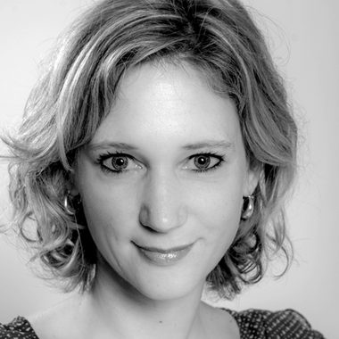

1. Asaad Taha

* Journalist, producer & Documentary filmmaker

Asaad is an Egyptian filmmaker, worked as a journalist for "Alhaya", "AlAhram", "AlSharq Alawsat" and more newspapers and weekly magazine. He also worked with TV channels such as "MBC", "AlJazeera" & "AlAraby TV".

He Produced 25 documentary series, around 900 hours of documentaries which covered more than 80 countries around the world.

He interviewed presidents, rebels and kings; like "Ali Ezzat Begovic" & "the Dalai Lama".

* Awards:
* Best Documentary Program at Cairo Film Festival, 1997.
* Best Documentary at Kazan International Film Festival 2006 for making "El dorado".
* Best Documentary at Kazan International Film Festival 2007 for the Film "Seven Tents".
* Honored at the 2010 MIP Cannes Festival.
* Honored at East Europe Documentary Film Festival in Asilah, Morocco in 2014.

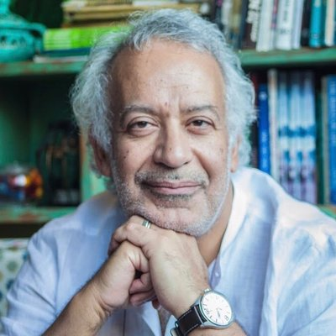

1. Madeleine Leroyer

* Documentary filmmaker

Madeleine is a French documentary filmmaker. Her debut film #387 premiered at IDFA 2019 and received several festival awards.

* Awards:
* 2nd prize at the GMFF 2019 for the documentary #387.
* Prix de la Clairière at FIFDH 2020 for the documentary #387.
* Best Documentary Award at FIFF2020 for the documentary #387.
* #387 Film will be shown on TV in over 15 countries.

